MAGNUM LUXE SALTED CARAMEL 8X440ML
Launch Information Document [LID]
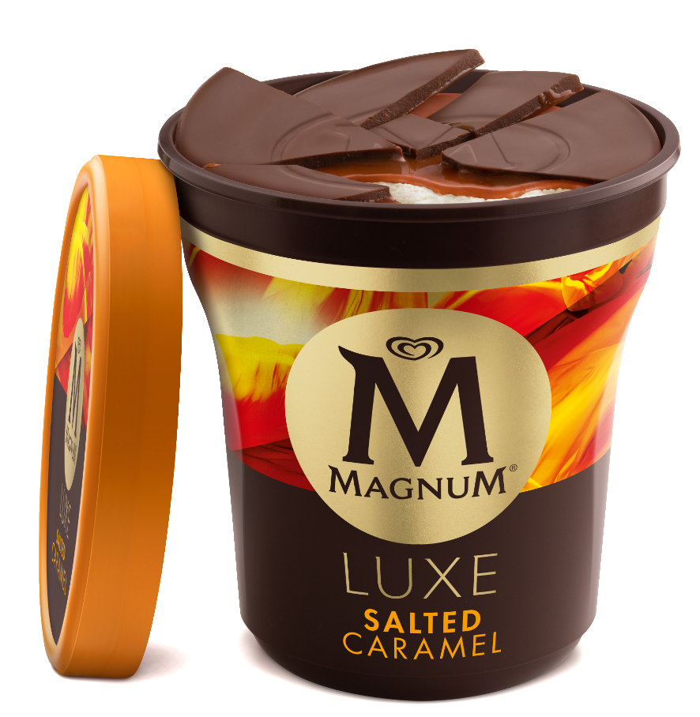

DESCRIPTION: Vanilla ice cream, layered with luscious salted caramel sauce and chocolate pieces, covered in in a cracking Magnum chocolate shell
SIZE: 440mL Ctn 8
PRODUCT AVAILABILITY DATES:
- SA – WK03 – 13/01/2020
- STT – WK05 – 27/01/2020

PRODUCT CODES, SIZES & APNs:
NEW CODE | PRODUCT | APN | TUN
67722583 | MAGNUM LUXE SALTED CARAMEL 8X440ML | 9300830050635 | 19300830041265

PRICING:
WHOLESALE LIST PRICE: | $49.6
GST: | $4.96
TOTAL (INC GST): | $54.56
TOTAL (INC GST) per tub: | $6.82
RRP: | $9.50
UNITS / OUTER: | 8

SPECIFICATIONS:

CARTONS PER LAYER: | 14
LAYERS PER PALLET: | 8
CARTONS PER PALLET: | 112
PALLET TYPE AND SIZE (LxWxH): | 1165 x 1165 x 1086mm
PALLET WEIGHT: | 333.872 NETT
UNIT SPECS (LxWxH): | 99 x 99 x 108mm 0.32 NETT
CARTON SPECS (LxWxH): | 384 x 194 x 117mm 2.808 NETT

